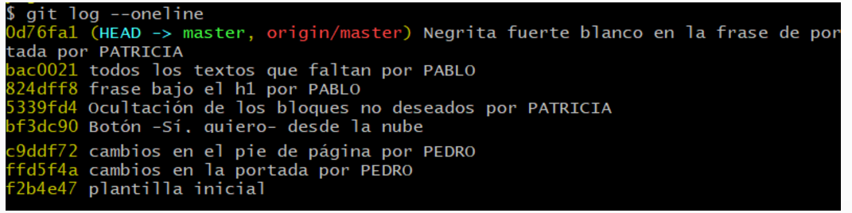
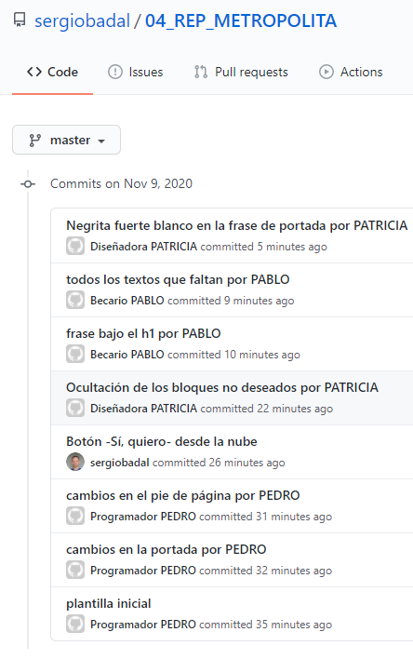 | 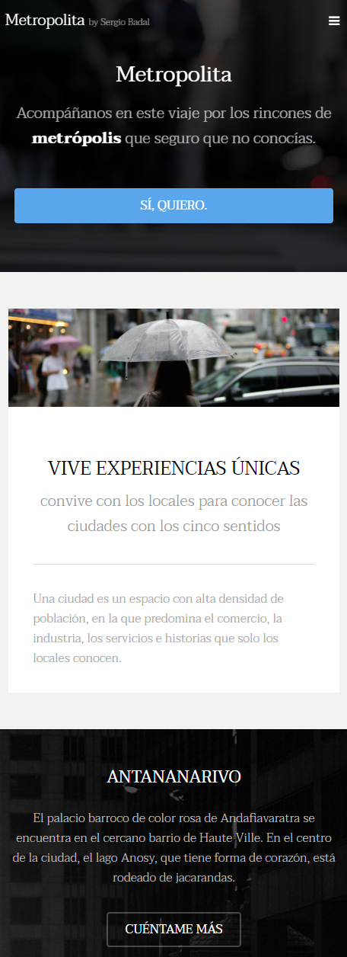
- https://github.com/sergiobadal/04_REP_METROPOLITA/
- https://metropolita.netlify.app/

